Economics Unit 1 Exam Semester 1 2017

Marking Guide

Section 1 (24 marks)

1 C
2 D
3 A
4 D
5 A
6 B
7 C
8 B
9 B
10 C
11 C
12 A
13 D
14 C
15 A
16 D
17 C
18 B
19 D
20 B
21 D
22 B
23 C
24 A

Section 2 (36 marks)

Question 25 (12 marks)

a i. Because world demand is increasing  D/S diagram – show D curve shifting to the right, increasing equilibrium price & qty  ii. Producers’ revenue will increase | 1 mark  1-2 marks  1 mark
b. Any 3 relevant factors – 1 mark each  1. Income – an increase in world income will increase world demand for coffee  2. Preferences/tastes – an increase in popularity will increase world demand for coffee  3. Population – an increase in world population will increase world demand for coffee | 1 mark  1 mark  1 mark
c. Adverse weather conditions that decreases the production of coffee e.g. drought  A decrease in Supply will increase equilibrium price and decrease equilibrium quantity | 1 mark  1 mark
d. Diagram showing an increase in D & an increase in S  Quantity will increase but price is indeterminate. Price may rise, fall or stay constant depending on which curve shifts more | 1 mark  1-2 marks

Marker’s comments: For all of Section Two the average mark was 24.2/36 which is 67%.
Question 25 Comments:
- a) i) Many students still not fully labelling their diagrams and forgetting to put in titles. It is imperative to do this otherwise marks lost. Some students not including a supply curve in their diagram, necessary to show new Pe and Qe. Some students need to review diagrams, demand increased, not supply increased/decreased.
- b) Explain means more than list
- c) Question states that world supply of coffee decreased yet some students discussed factors affecting demand.????
- d) review diagrams p 42 and table p43 of textbook

Question 26 (12 marks)

a. i. $20 & 100 million crates  ii. $2,000 million  iii. D/S Diagram showing equilibrium  Revenue rectangle shaded on diagram (see below) | 1 mark  1 mark  1 mark  1 mark
b. i. To support/increase revenue for orange growers  ii. 80 million crates  iii. Producers will be better off  Their revenue will increase by $400 million | 1-2 marks  1 mark  1 mark  1 mark
c. Diagram showing the price floor (see below)  The price floor is inefficient because it decreases total surplus – it creates a deadweight loss (show on diagram) | 1 mark  1-2 marks

Marker’s comments:
- a) i) must include $ and values (m, b) or ½ marks only.
- ii) simple calculation $20 x 100m crates
- iii) need to label whole area representing producer revenue. Many shaded producer surplus only so incorrect
- b) iii) many students wrote that producers were not better off and did not calculate that revenue had increased after price floor imposed.
- c) Many students need to review price floor diagram, esp position of DWL – p91 of text

Question 27 (12 marks)

a. i. $18 and 52 million  ii. $28 and 46 million  iii. Size of tax = $12  iv. Tax revenue = $552 million | 1 mark  1 mark  1 mark  1 mark
b. P.E.D = 6/49 x 23/10 = 0.28  Demand is inelastic  Cigarettes are very addictive, habit forming | 1 mark  1 mark  1 mark
c. Tax incidence - the division of the tax burden between buyers and sellers (how much of the tax is paid by buyers & by sellers)  Consumers pay $10 of the tax  Producers pay $2 of the tax | 1 mark  1 mark  1 mark
d. 1. Taxing goods that are inelastic raises more revenue than taxing elastic goods  2. Taxing goods that are inelastic creates a smaller deadweight loss than taxing elastic goods | 1 mark  1 mark

Marker’s comments:
a) i) and ii) $ and values many students not including in answers.
iii) Many could not work out size of tax. Many wrote $10. $12 because consumer pay $10 and producer pay $2
iv) Many students could not work out tax revenue (size of tax x quantity) ie. $12 x 46m
b) Many students got this wrong. Need to know mid-point method for calculation PED – Review
c) Many students need to review their understanding of the concept of the incidence of a tax.
Section 3 (40 marks)

Answer TWO questions

Question 28 (20 marks)

a. Using examples, explain both the law of demand and the law of supply. (10 marks)

b. Explain the concept of market equilibrium and distinguish between a shortage and a surplus. Explain how the price mechanism will clear both a shortage and a surplus. (10 marks)

a. 5 marks – law of demand  State the law of demand – negative relationship between P & Qty  Appropriate example  Draw a diagram showing a downward sloping D curve  Reasons for the law of demand – explain the substitution effect & the income effect  5 marks – law of supply  State the law of supply – positive relationship between P & Qty  Appropriate example  Draw a diagram showing an upward sloping S curve  Reasons for the law of supply – explain the substitution effect & the income effect | 1 mark  1 mark  1 mark  1-2 marks  1 mark  1 mark  1 mark  1-2 marks
b. Meaning of market equilibrium – where qty demanded equals qty supplied (intersection of D & S curves)  Diagram showing market equilibrium  Shortage – price is below the equil price: qty demanded exceeds qty supplied  Surplus – price is above the equil price: qty supplied exceeds qty demanded  Diagram showing shortage & surplus  Explanation of how a shortage & a surplus are cleared | 1-2 marks  1 mark  1-2 marks  1-2 marks  1 mark  1-2 marks

Question 29 (20 marks)

a. Using the concepts of consumer and producer surplus, explain why a competitive market is efficient. (10 marks)

b. Choose either a price ceiling or a subsidy. Explain the reasons why the government would use such a policy and use a model to explain the effects of the policy on market efficiency.
(10 marks)
a. Definition of consumer surplus – difference between the maximum price a consumer will pay and the actual price they pay  Diagram showing consumer surplus  Definition of producer surplus – difference between the minimum price a producer must receive and the actual price they receive  Diagram showing producer surplus  Explain why a competitive market is efficient – 2 marks  At equilibrium, total surplus (sum of consumer & producer surplus) is maximised. This is the defn of market efficiency – maximum net benefits for society  Any output that is either above or below the equilibrium qty will cause a deadweight loss – a decrease in total surplus  Supporting diagram – 2 marks | 1-2 marks  1 mark  1-2 marks  1 mark  1-4 marks
b. Choose price ceiling OR subsidy  Define & provide an example  Reasons – to either support consumer group (price ceiling) or producer group (subsidy)  Correctly labelled diagram showing the price ceiling or subsidy relative to the equilibrium price and deadweight loss.  Explanation of diagram:  - PC legislated price is below equilibrium price results in shortage because Qd exceeds Qs OR  - Subsidy causes S curve to shift down by amount of subsidy causing P to fall and Q to fall  Explain effects on market efficiency – explain the change to consumer surplus, producer surplus & total surplus. In both cases, there will be a DWL – show on diagram.  - PC – increase CS but PS decreases by more causing a decrease in TS – a DWL. PC has resulted in the market failing to produce the optimal quantity and is therefore inefficient.  - Subsidy – increase in CS b/c consumers pay less and receive more, increase in PS b/c producers receive higher price and sell more, however the cost of subsidy is greater than the combined increase in CS and PS, therefore TS reduced as DWL created, therefore inefficient  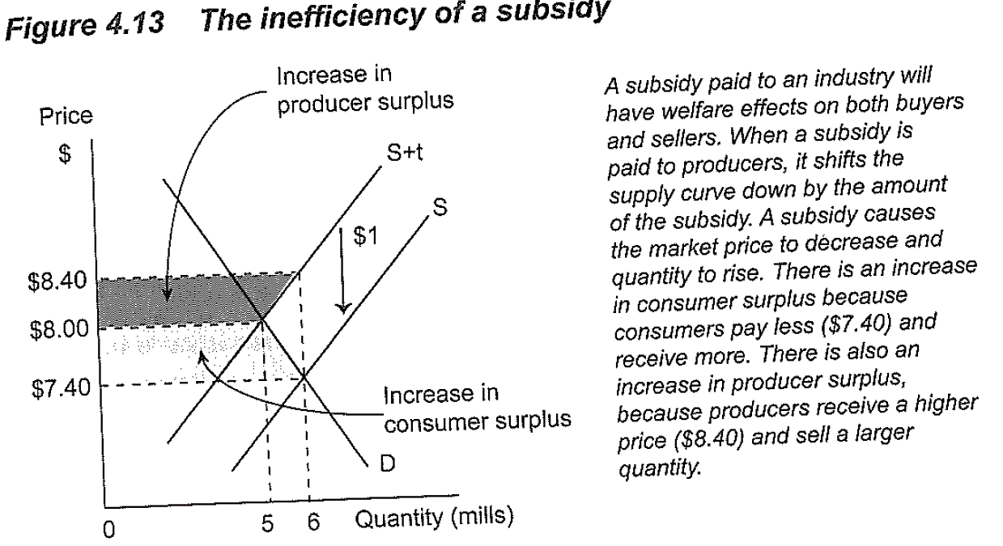  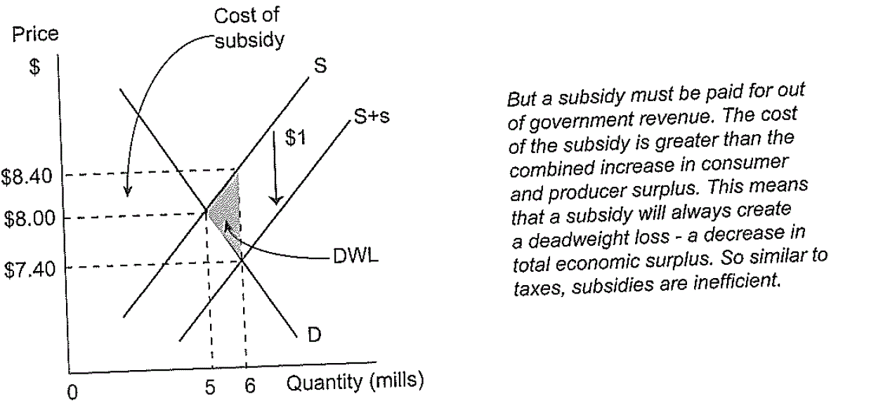  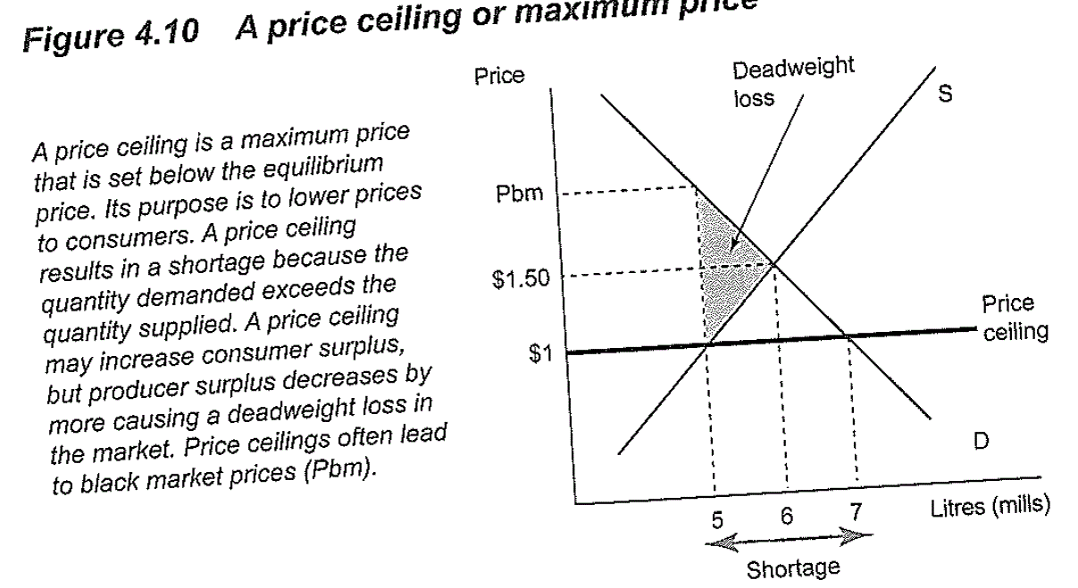 | 1-2 marks  1-2 marks  1-2 marks  1 mark  1-3 marks
Marker’s Comments: 11 students attempted this question. Average mark was 10.3/20 – 51.5%

a) Many students did not define CS or PS in their response. Some did not include diagrams showing CS and PS.
Supporting diagram – p89 of text. Marks were awarded if student mentioned monopoly if underproduction occurred.

b) Review definition of subsidy – payment or grant paid to producer with the purpose of reducing costs and increasing output .
Many students not provide a valid example of a production subsidy to assist high cost producers i.e. Australian car manufacturers, many farmers.
Students need to review their diagrams esp subsidy diagram (p 96) and DWL in price ceiling diagram (p92)
Many students were confused in relation to a subsidy and the effect on market efficiency with a subsidy correcting market failure. They are not the same – need to review

